User Manual:

* Download the RAR part files in the Github. Extract the part files into an apk file and install it onto the device. A screen should show like this.

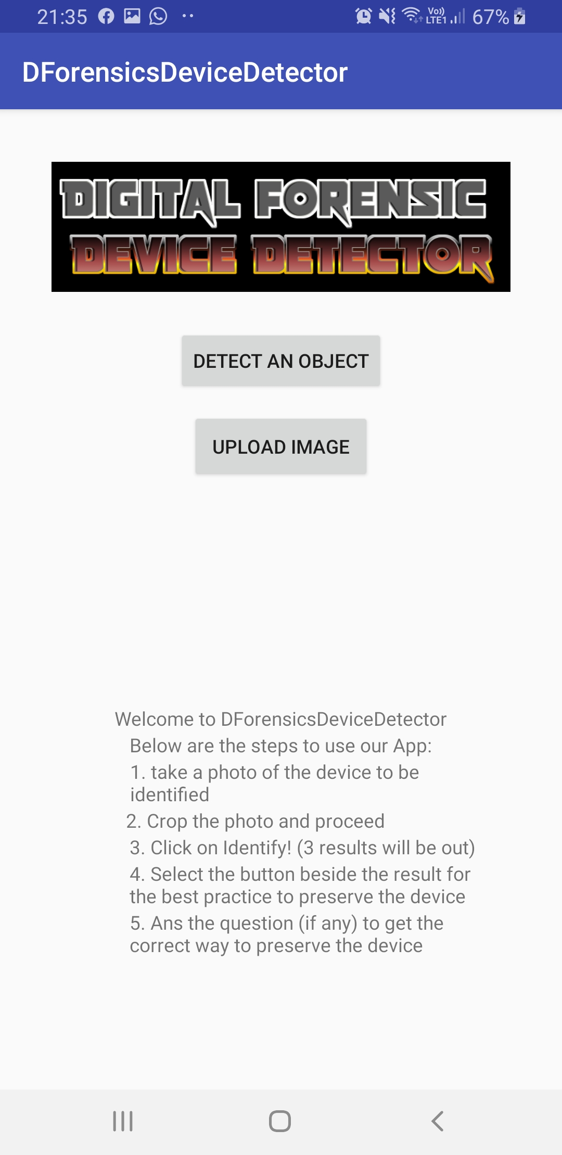

* When our program is launched on the mobile device, a home page will be shown to the investigator.
* Instructions will be displayed on the home page to guide the user on how to use the application.
* Users can choose to “DETECT AN OBJECT” or “UPLOAD IMAGE”.

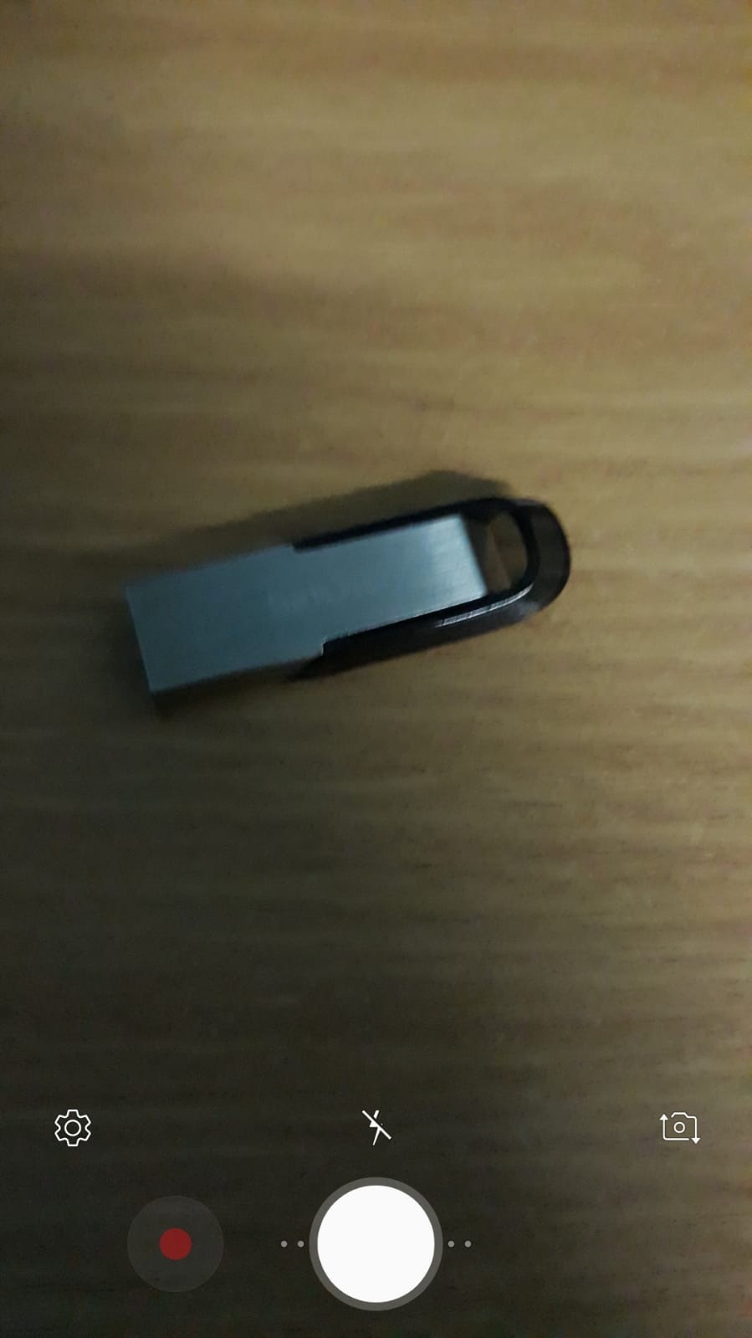

* Once the “DETECT AN OBJECT” button is pressed, the application will open up the mobile camera while it awaits the investigator to take a picture.

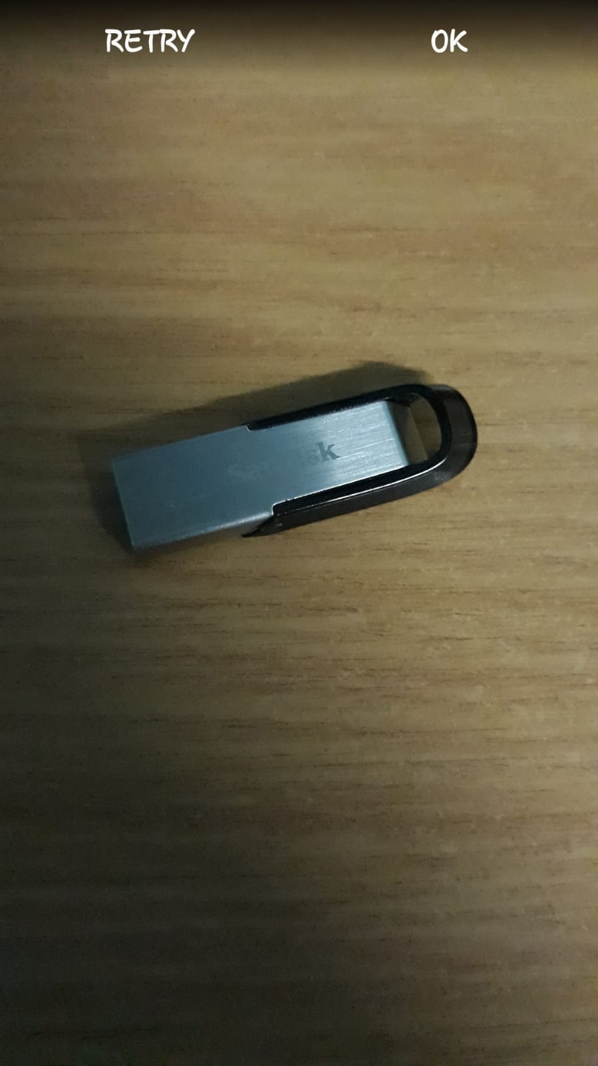

* Once the user had taken a picture, the application will prompt the user if he wishes to analyse the picture or retake the photo.
* The photo taken will be stored into the smartphone’s storage.

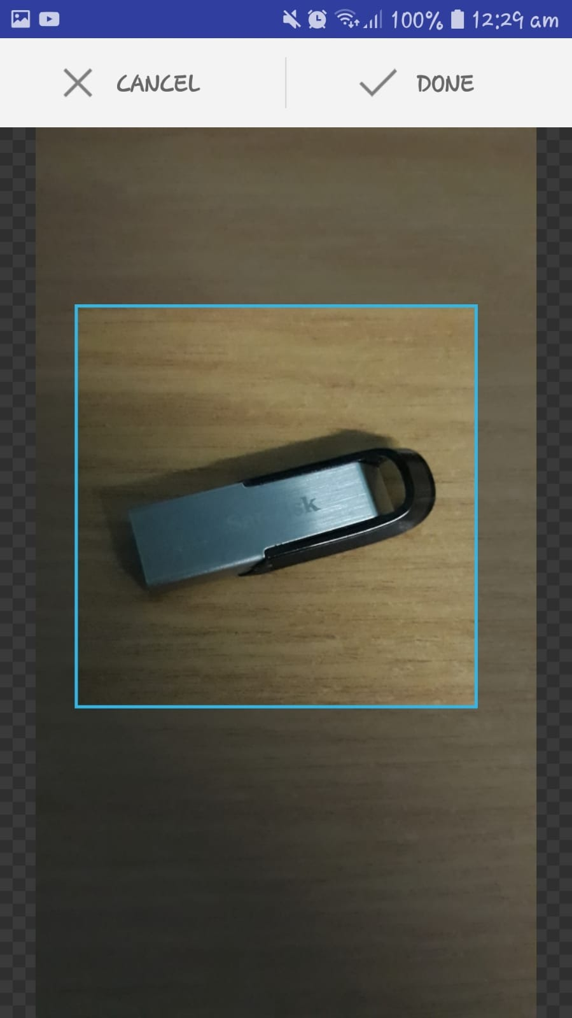

* Once the photo is taken, the investigator will have to crop the device so as to make the analysis more accurate.

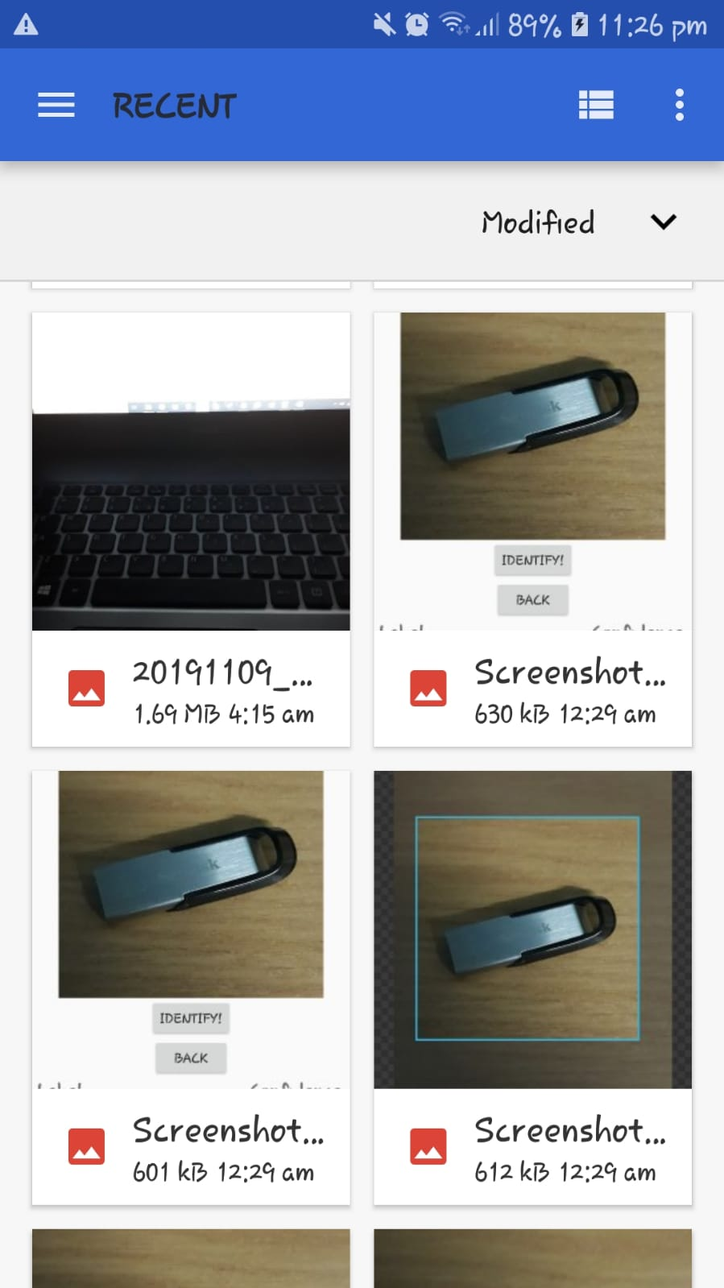

* If the user chooses to “UPLOAD IMAGE”, the application will divert to the gallery page for the user to select a photo.



* Once the photo is selected, the investigator will have to crop the device so as to make the analysis more accurate.

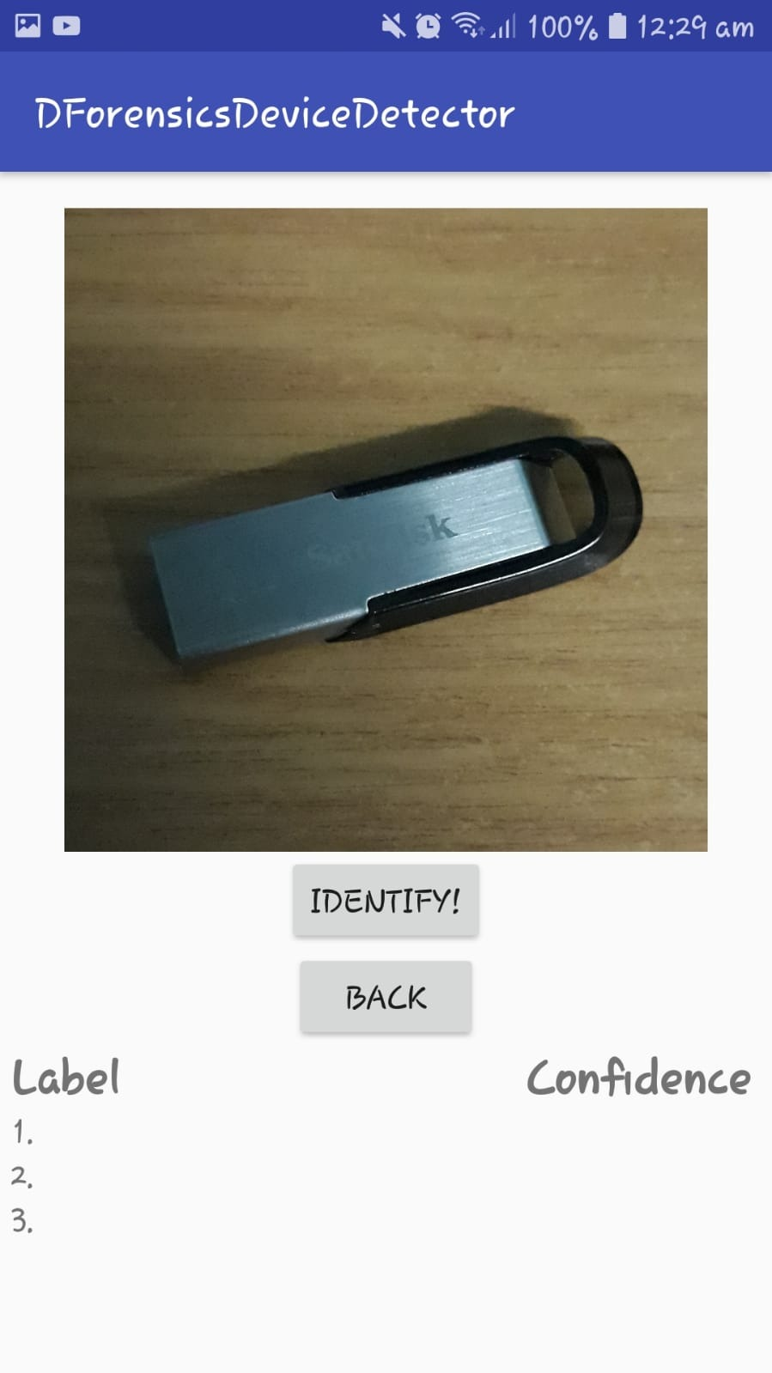

* Once the cropping is done, the application will be redirected to a new page, prompting the investigator if he wishes to identify the image or goes back to the camera page.

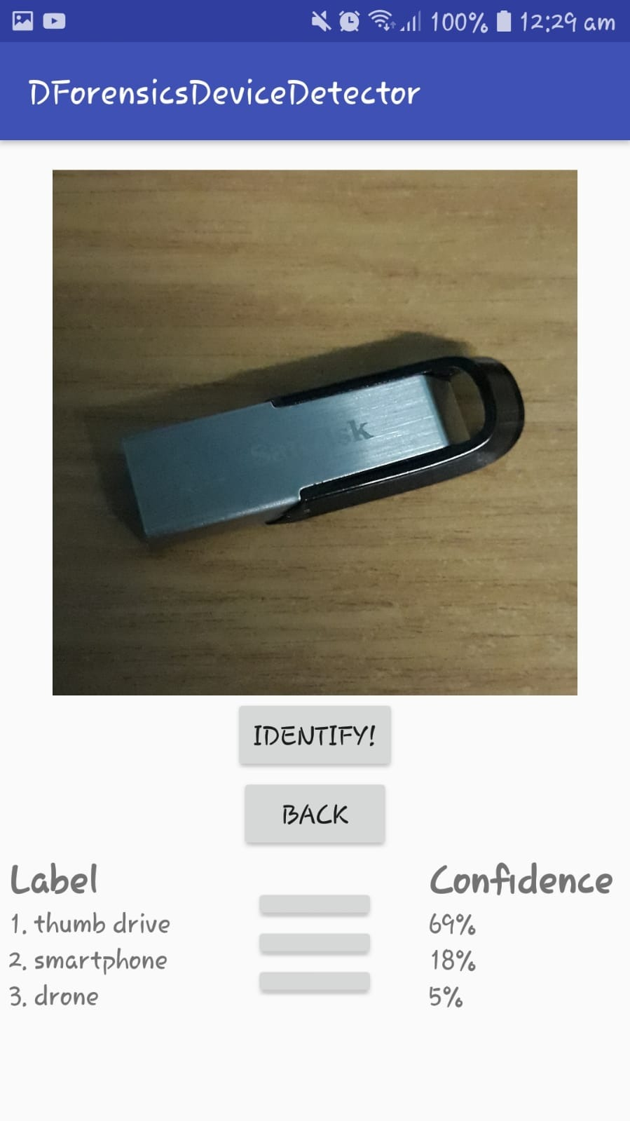

* If the “IDENTIFY!” button is clicked, the program will analyze the image before displaying its analysis.
* The label depicts what the program thinks the device is and the Confidence is the statistic to show to what degree the program think the device is.
* By pressing the side buttons next to the label, it will redirect the user to the forensic information.

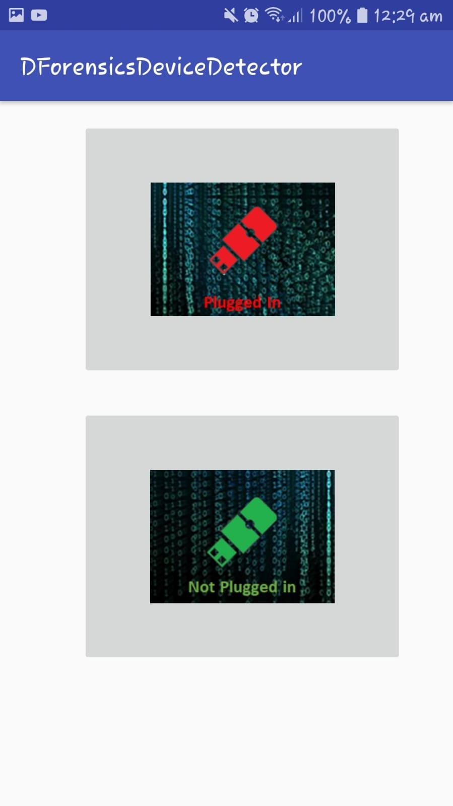

* If there are some states that the device is in, the program will prompt the user to choose the state of the device.

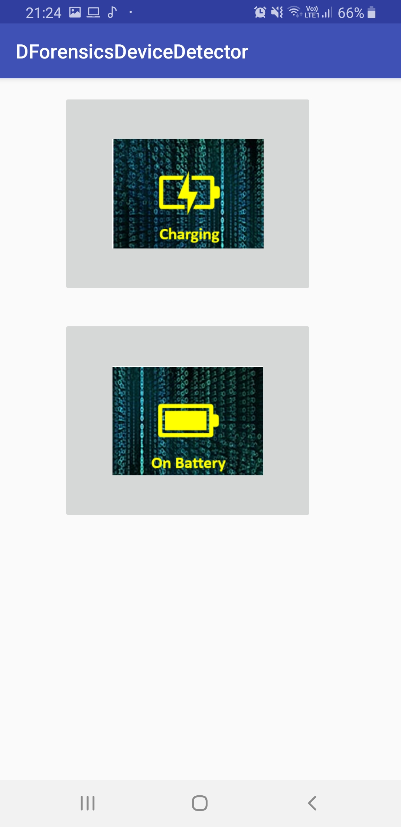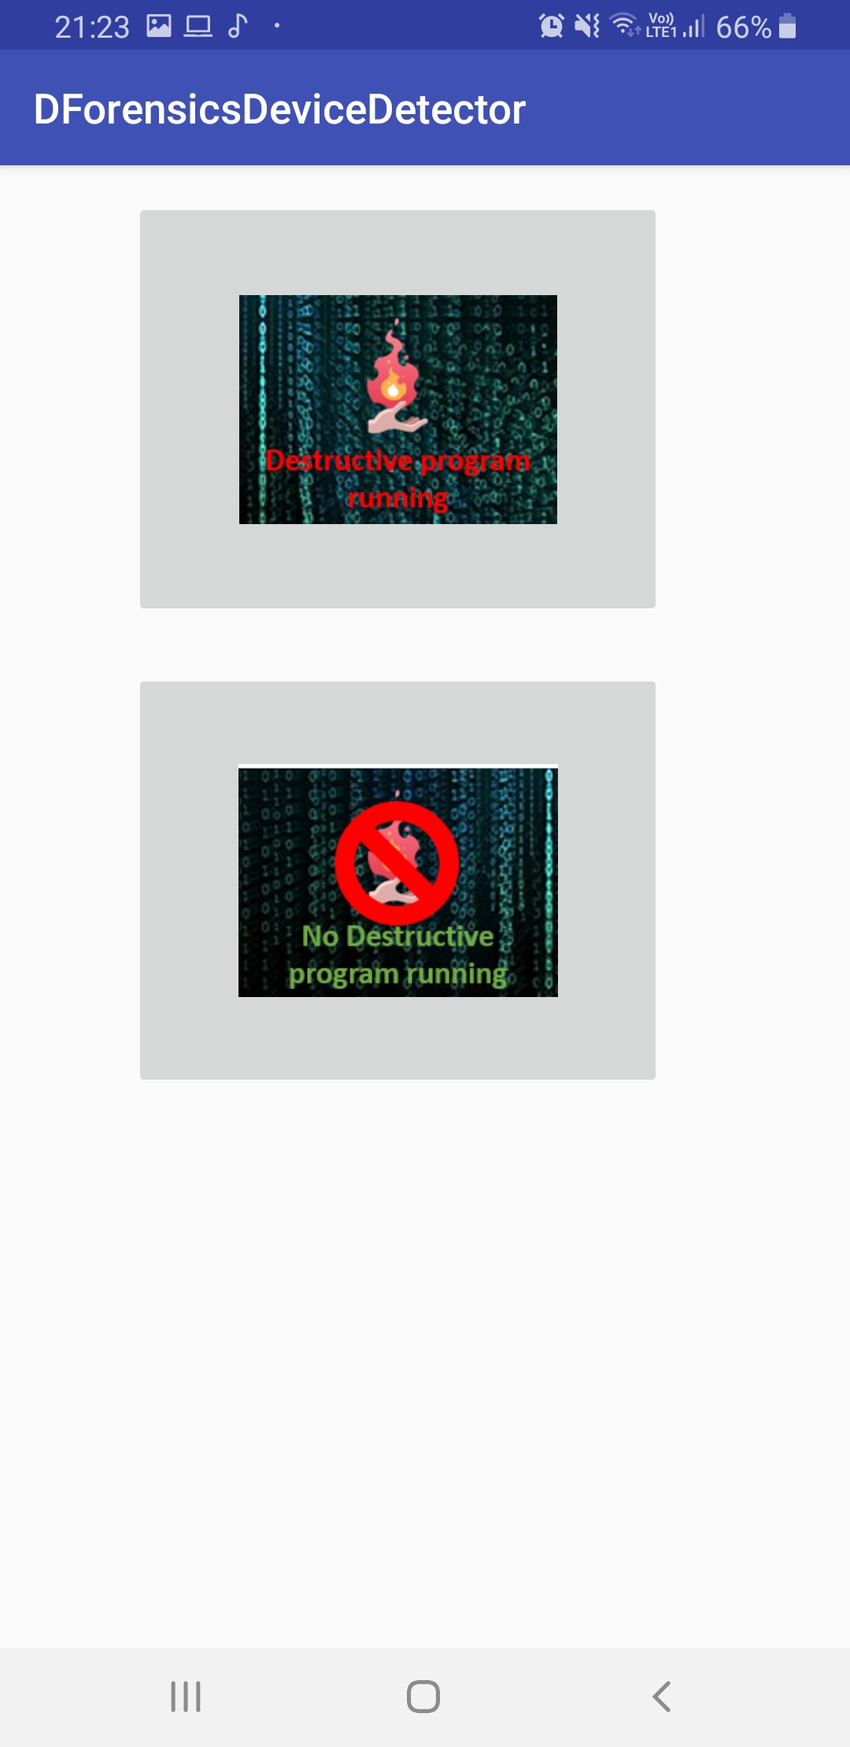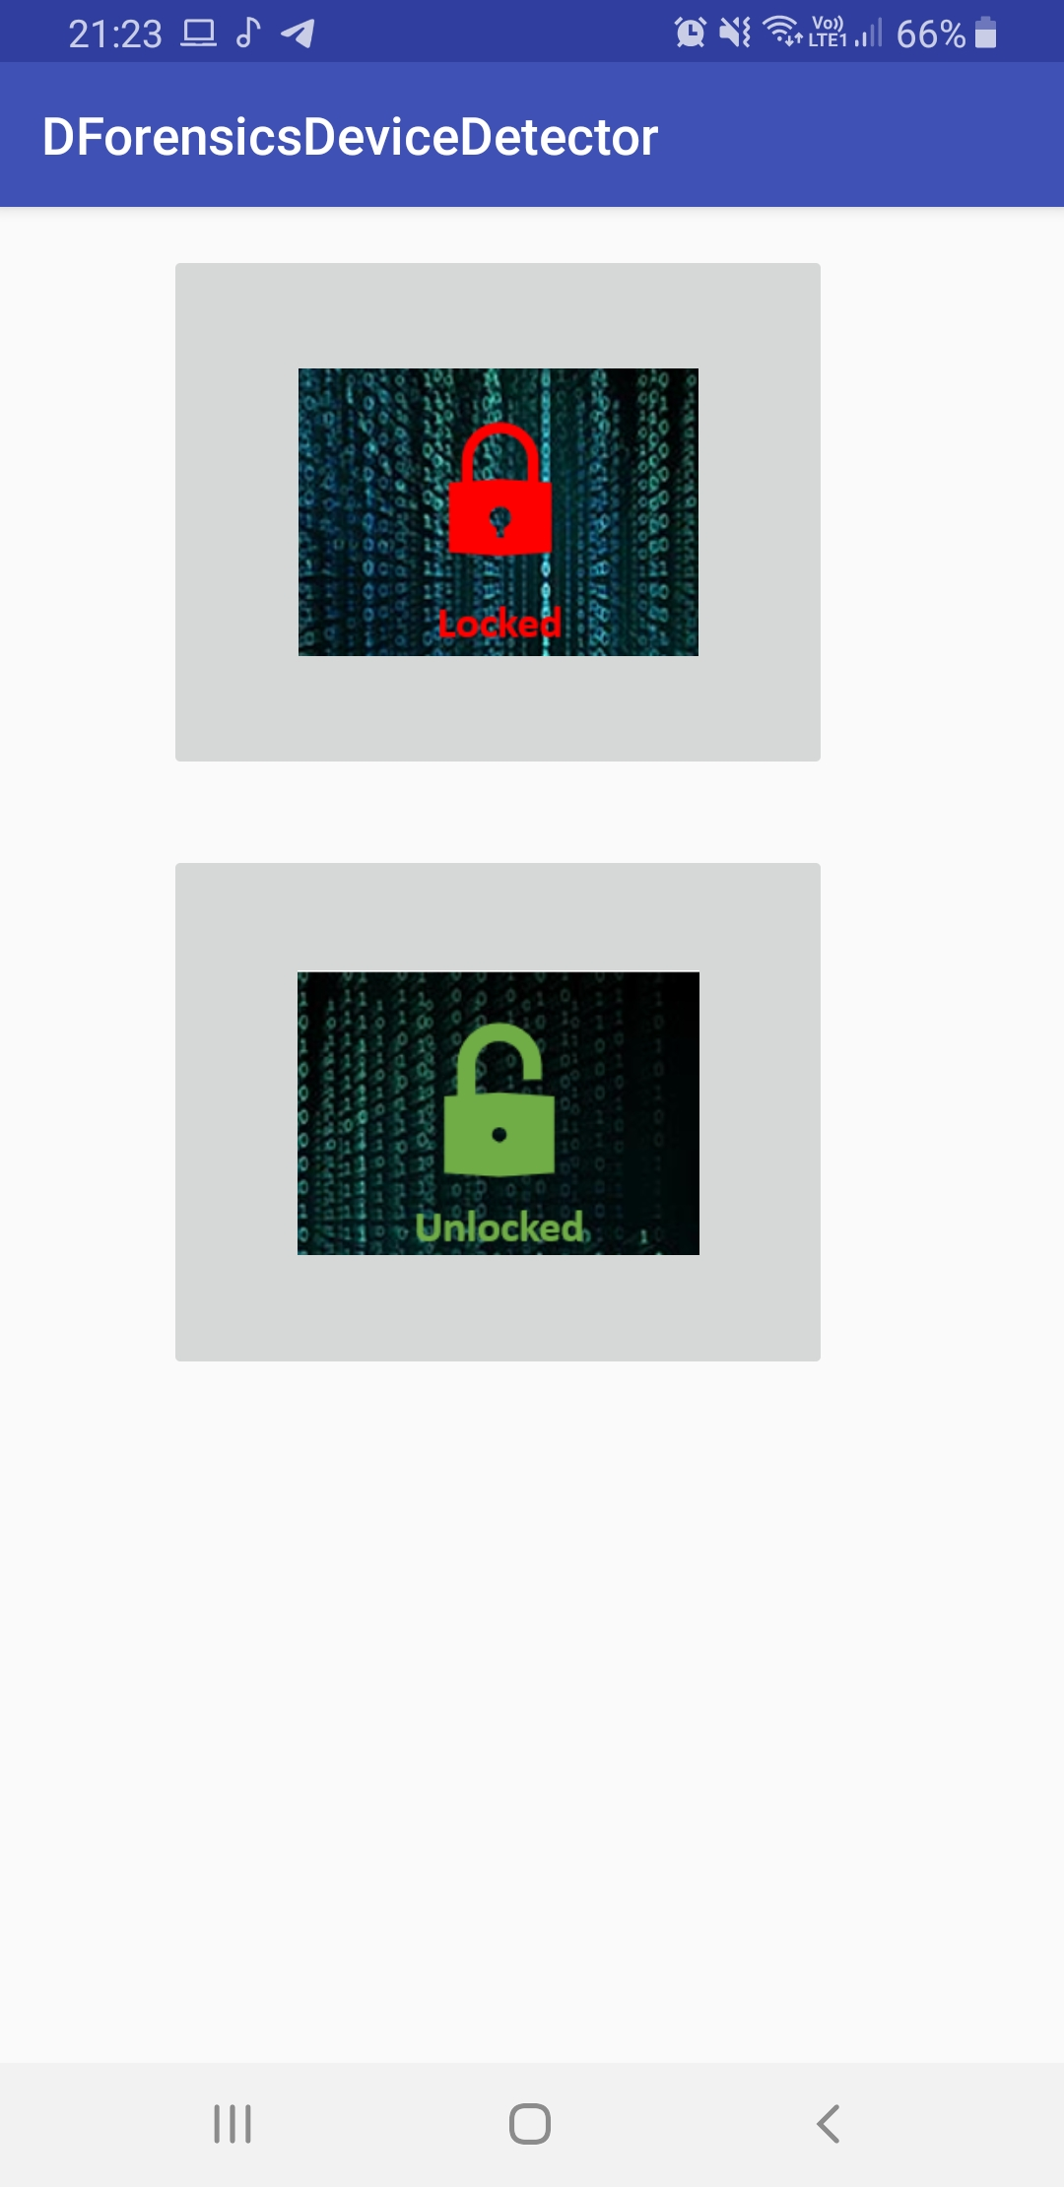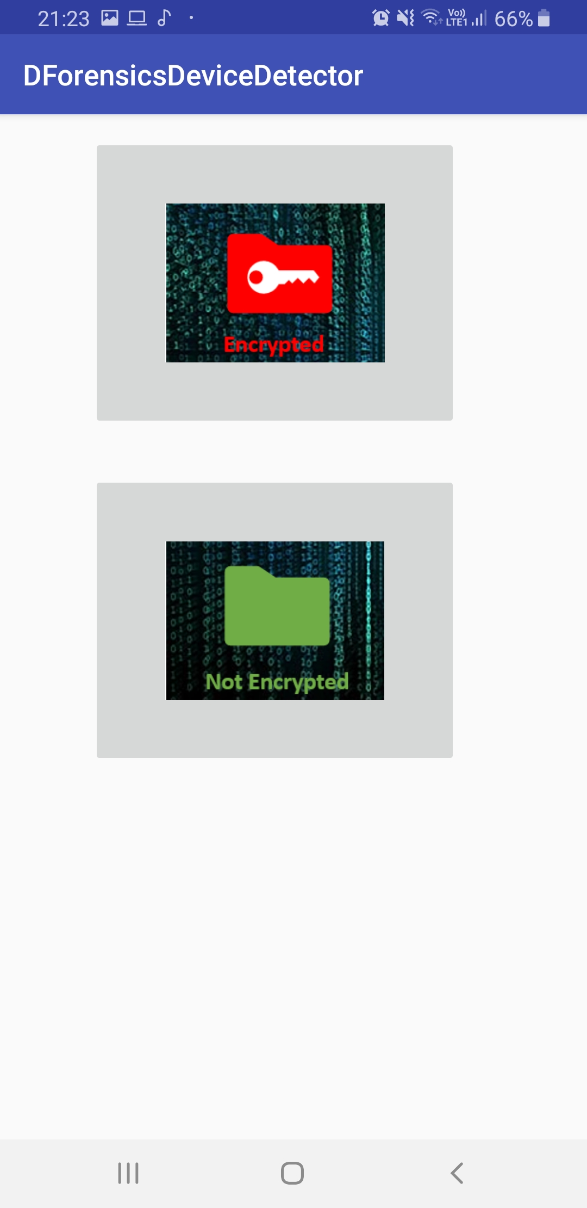

* Above are some of the states that could appear in the program.

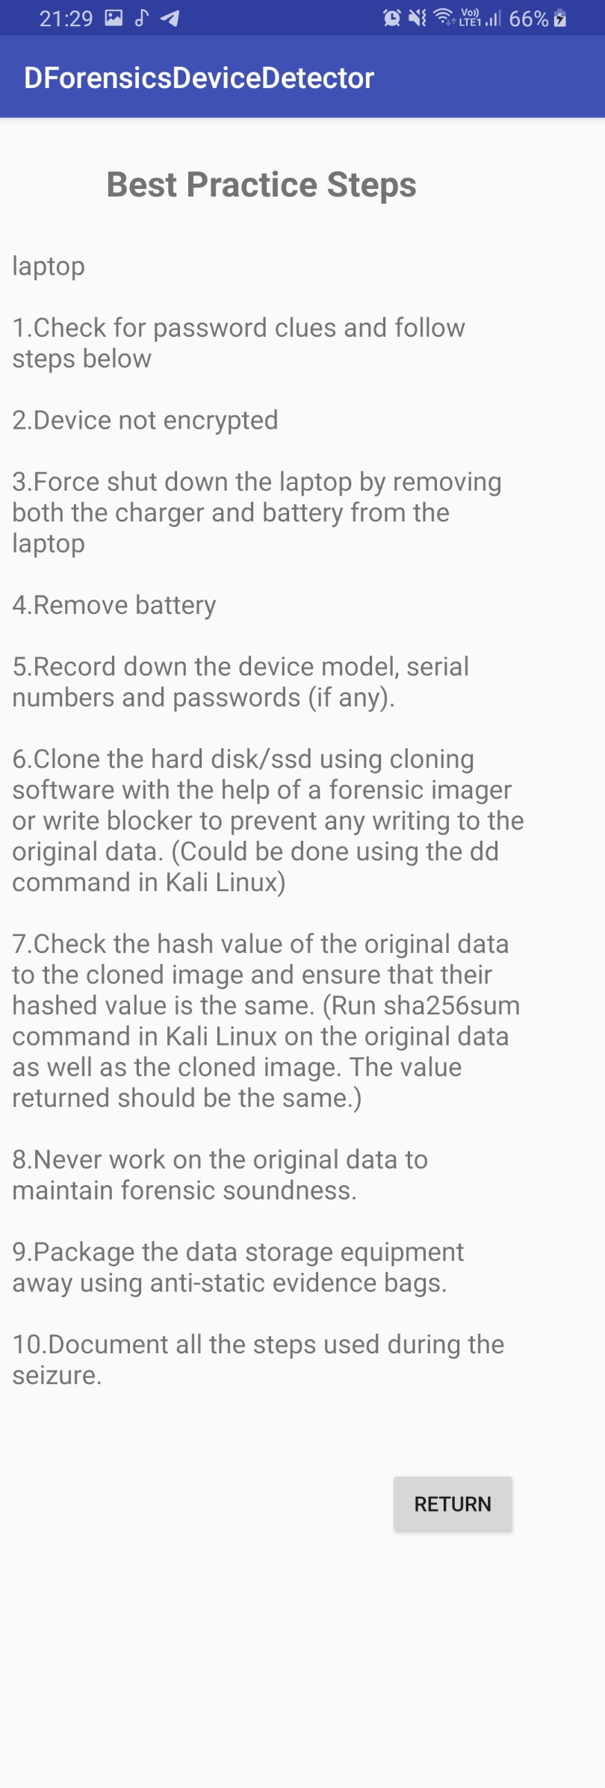

* Upon answering the different state of the user, the program will output the necessary steps to extract the device forensically soundly.
* User can select the return option to return to the home page to commence detection of another object.